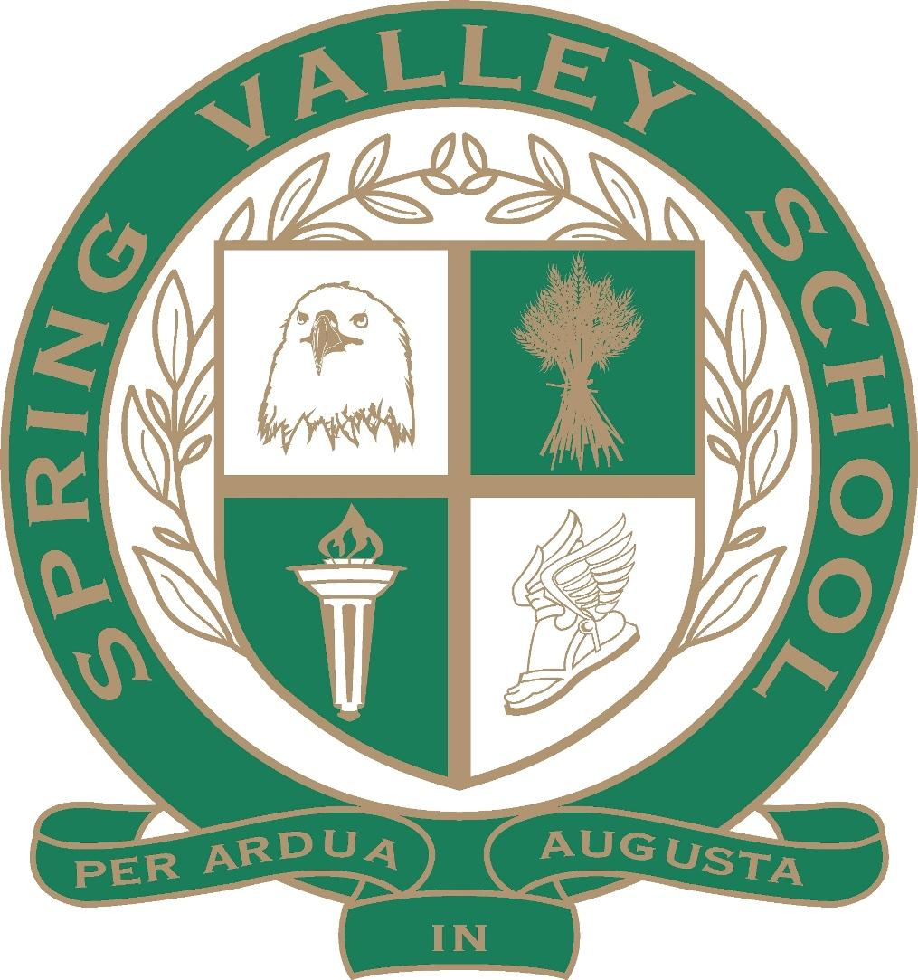

Middle School Summer Reading 2022
(Rising 6th & 7th Graders)

Graded Activity
Due the first week of school in August

Join 2022 Summer Reading Google Classroom
https://classroom.google.com/u/0/c/NTEwNDE0MTE4NjQ5

All SVS middle school students are expected to read at least TWO books this summer. Students must read one fiction book and one nonfiction book. Assignment details are listed below. Summer reading packets will be graded; they are due the first week of the school year.

Instructions:
- Pick a good book.
Select a book that appeals to you and is age- and grade-level appropriate. Below are links to books lists and websites that may help you find books that interest you. Your local library is a great resource for selecting books, too!
- Goodreads’s Best Middle School Books (multiple lists by topic/genre)
- Parents' Choice Best 25 Books Age 10+
- School Librarian Book Suggestions
- Newbery Winners
- Classics
- Middle School Nonfiction
- Learning Ally

- Read and record.
You may either read with your eyes or with your ears (e.g., via audio books, family read alouds, etc.). Students who ear-read are strongly encouraged to follow along with their eyes as they listen, as this builds their tracking skills, fluency, and sight word vocabulary.

Record each book you read in your book log.

- Rate the book.
Rate each book on a scale from one to five stars. Complete one rating sheet per book.

- Return your book log.
Book logs and rating sheets are due the first week of the school year. This will count as a grade.

Book Log

Title | Author | Fiction/  Nonfiction | Pages | Read with eyes or ears? | Parent Signature

Book Log (Continued)

Title | Author | Fiction/  Nonfiction | Pages | Read with eyes or ears? | Parent Signature

Title: __________________________________
Author: __________________________________

Directions:
- Rate the book using the five-star rating system (1 star means the book was terrible; 5 stars means the book was awesome).
- Defend your rating by giving at least three reasons why you did or didn’t like the book. Use complete sentences.

I would rate this book ____ stars, because__________________________________________________________
________________________________________________________________________________________________________________________________________________________________________________________________________________________________________________________________________________________________________________________________________________________________________________________________________________________________________________________________________________________________________________________________________________________________________
Title: __________________________________
Author: __________________________________

Directions:
- Rate the book using the five-star rating system (1 star means the book was terrible; 5 stars means the book was awesome).
- Defend your rating by giving at least three reasons why you did or didn’t like the book. Use complete sentences.

I would rate this book ____ stars, because__________________________________________________________
________________________________________________________________________________________________________________________________________________________________________________________________________________________________________________________________________________________________________________________________________________________________________________________________________________________________________________________________________________________________________________________________________________________________________

